SUM OF SERIES

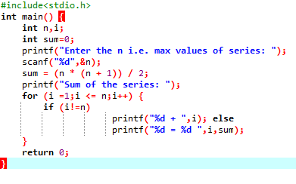

OUTPUT

